SP Capstone Project 1 Final Report



## **1. Define the Problem**

# Predict whether the customer will purchase again or not in the next 12 months after the first purchase is completed.

## **2. Prepare Data for Consumption**

## **2.1 Gather the Data:**

(1) Explore a ecommerce store data in multiple tables

There are three tables:

* **Order information table** contains 840k rows and 15 columns. This table has all customers purchasing order information.
* **Product information table** includes customers’ first purchasing order. This table has 66K rows and 13 columns.
* **Customer information table** has about 0.5MM rows/unique customers and 19 columns. This table also contains customers’ first purchase information.

There is detailed table information.

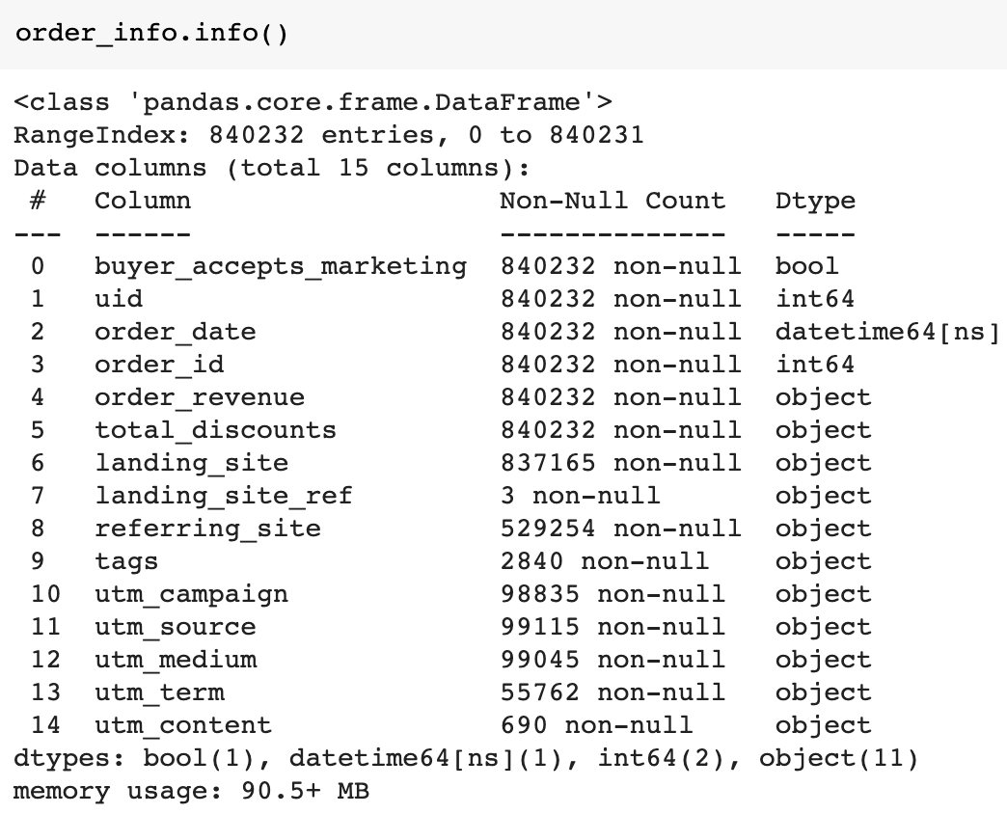

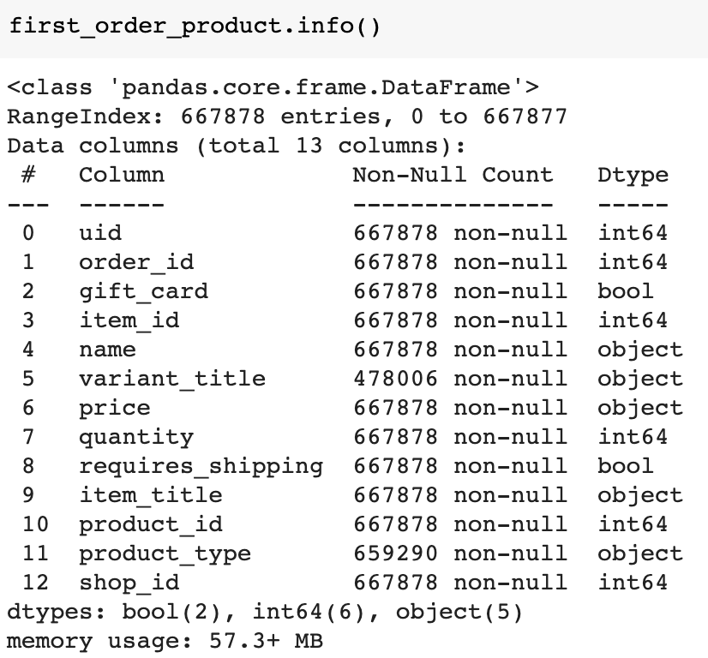

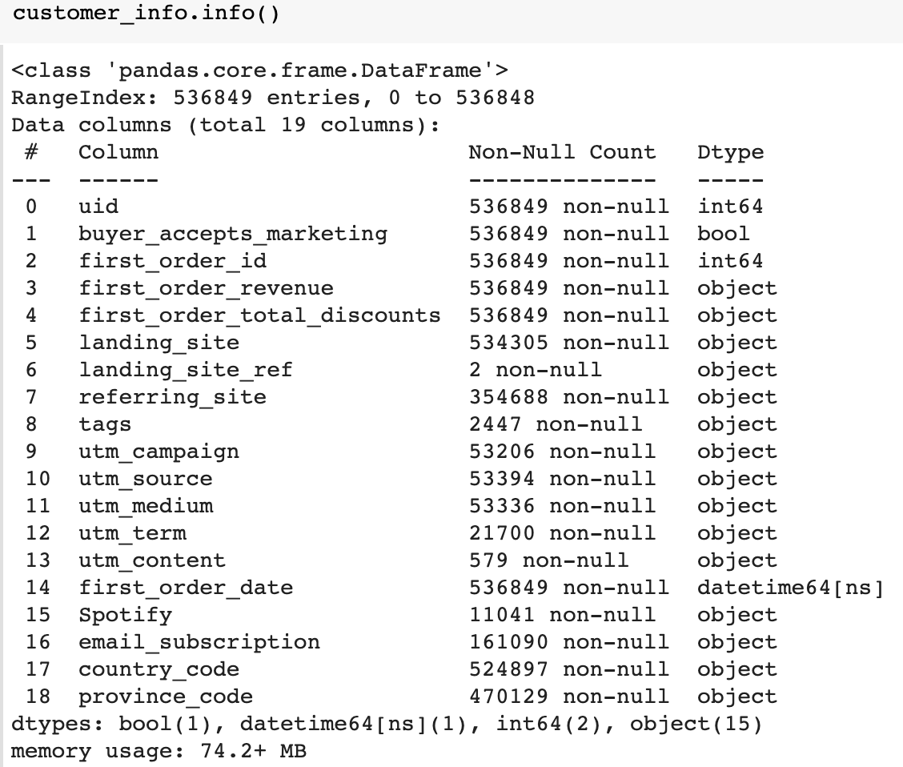

From the three tables, we have **numerical variables** (such as price and order revenue), **categorical variables** (eg. country_code), **binary variables** (eg, buyer_accepts_marketings), **string variables** (eg product_title, landing_site and etc) and **time variable** (eg. date).

Some **special variables** might carry richer information than others.

* Order date: the **holidays or seasonality** can be extracted from. And these information might be useful for modeling
* Country_code and province_code are **geo variables**. Some customer location insights can be extracted.
* **NLP variables** such as item_title, landing_sites etc. They also contain some product features information and can be extracted via NLP process.

## **2.2. Prepare Data for Consumption:**

In this section, the data wrangling process has been applied to generate a final table for exploratory data analysis and machine learning.

1. Calculate Target Variable

The Target variable has to be created since the raw data source doesn’t provide. Based on the problem definition, a binary target variable should be generated in order to predict the binary classification problem.

Join keys ( uid and order_id) are used to calculate customers' total order frequency and total revenue during the 12 months since the first purchase for each customer. The target variable is created as ‘repeat_purchase’, the binary variable. The repeat_purcase = 1 when total order frequency>1 otherwise repeat_purchase =1

1. Filter out unuseful rows and columns

Based on the business definition, canceled or refund orders need to be filtered out.

1. Handling missing data

In my data set, only string or categorical variables contain missing data. So for categorical variables, new classes are created to reflect ‘null’ or ‘na’ in these variables. For string variables, they are turned into binary variables based on where the value is missing or not.

Luckily, all missing values are able to be filed based on business definition.

After this process, the final table has been created with 532,565 rows and 21 columns without any missing values in the table. And each row is a unique customer. The target variable is ‘repeat_purchase’, a binary variable.

## **3. Perform Exploratory Analysis:**

(1) Basic descriptive statistics: min, mean, median, quantiles, max

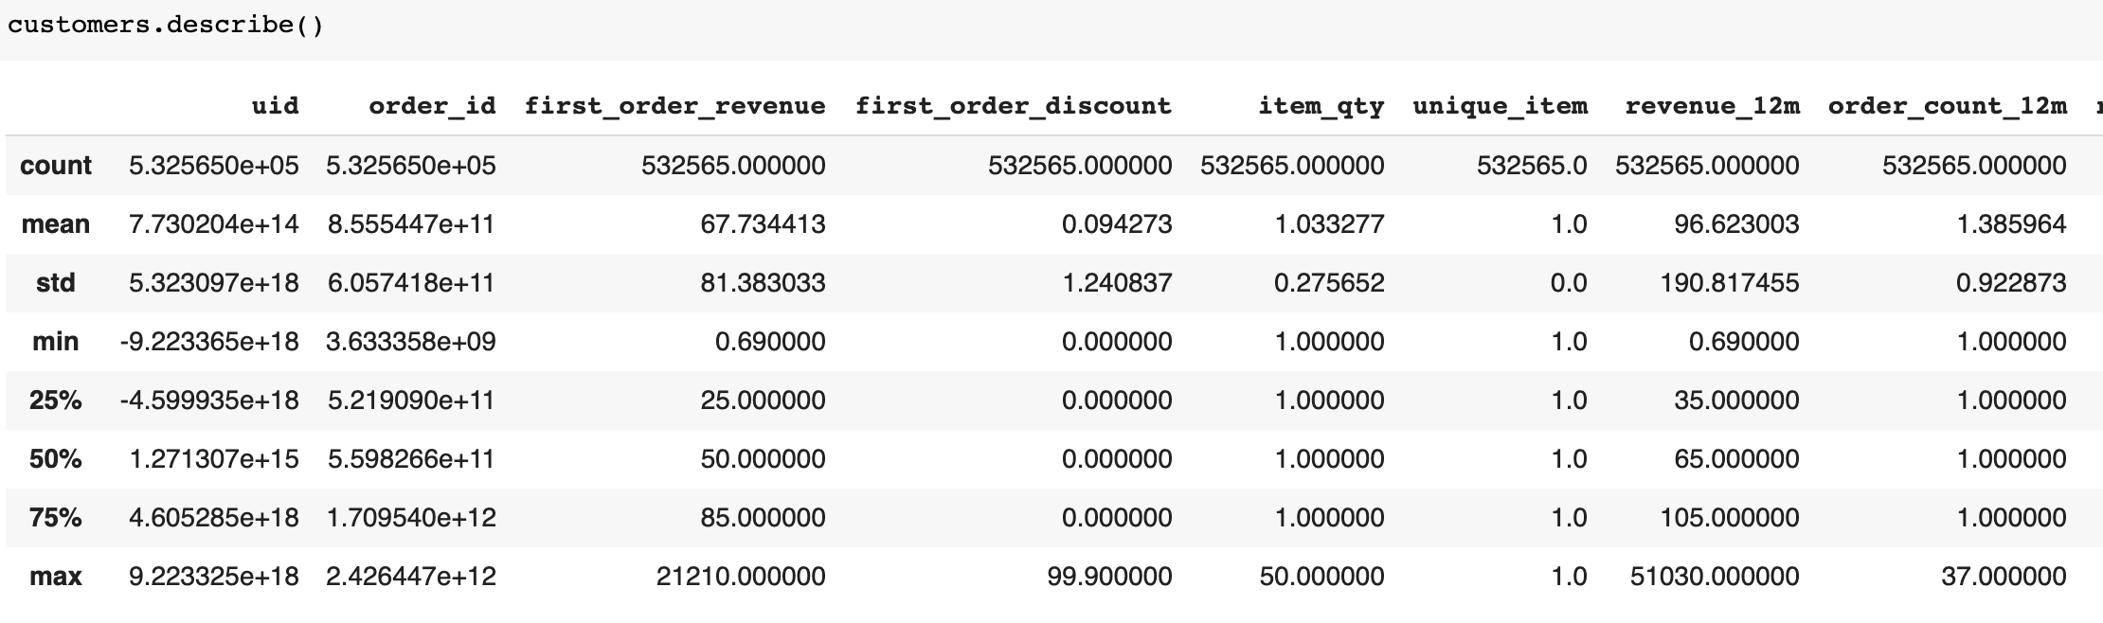

(2) Check distributions

* Bar chart of target variables. Majority of the customers are one-time purchasers.

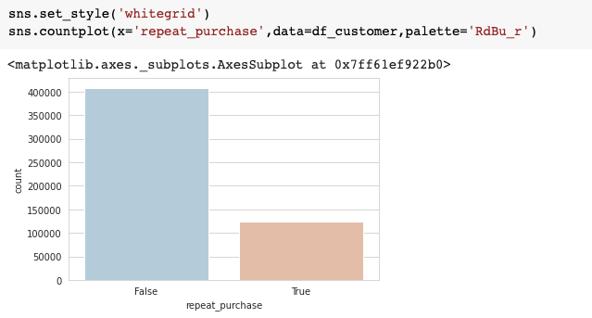

* Generate density plot of orde_count_12 (total order frequency per customer), revenue_12m (total revenue per customer) and first_order_revenue.

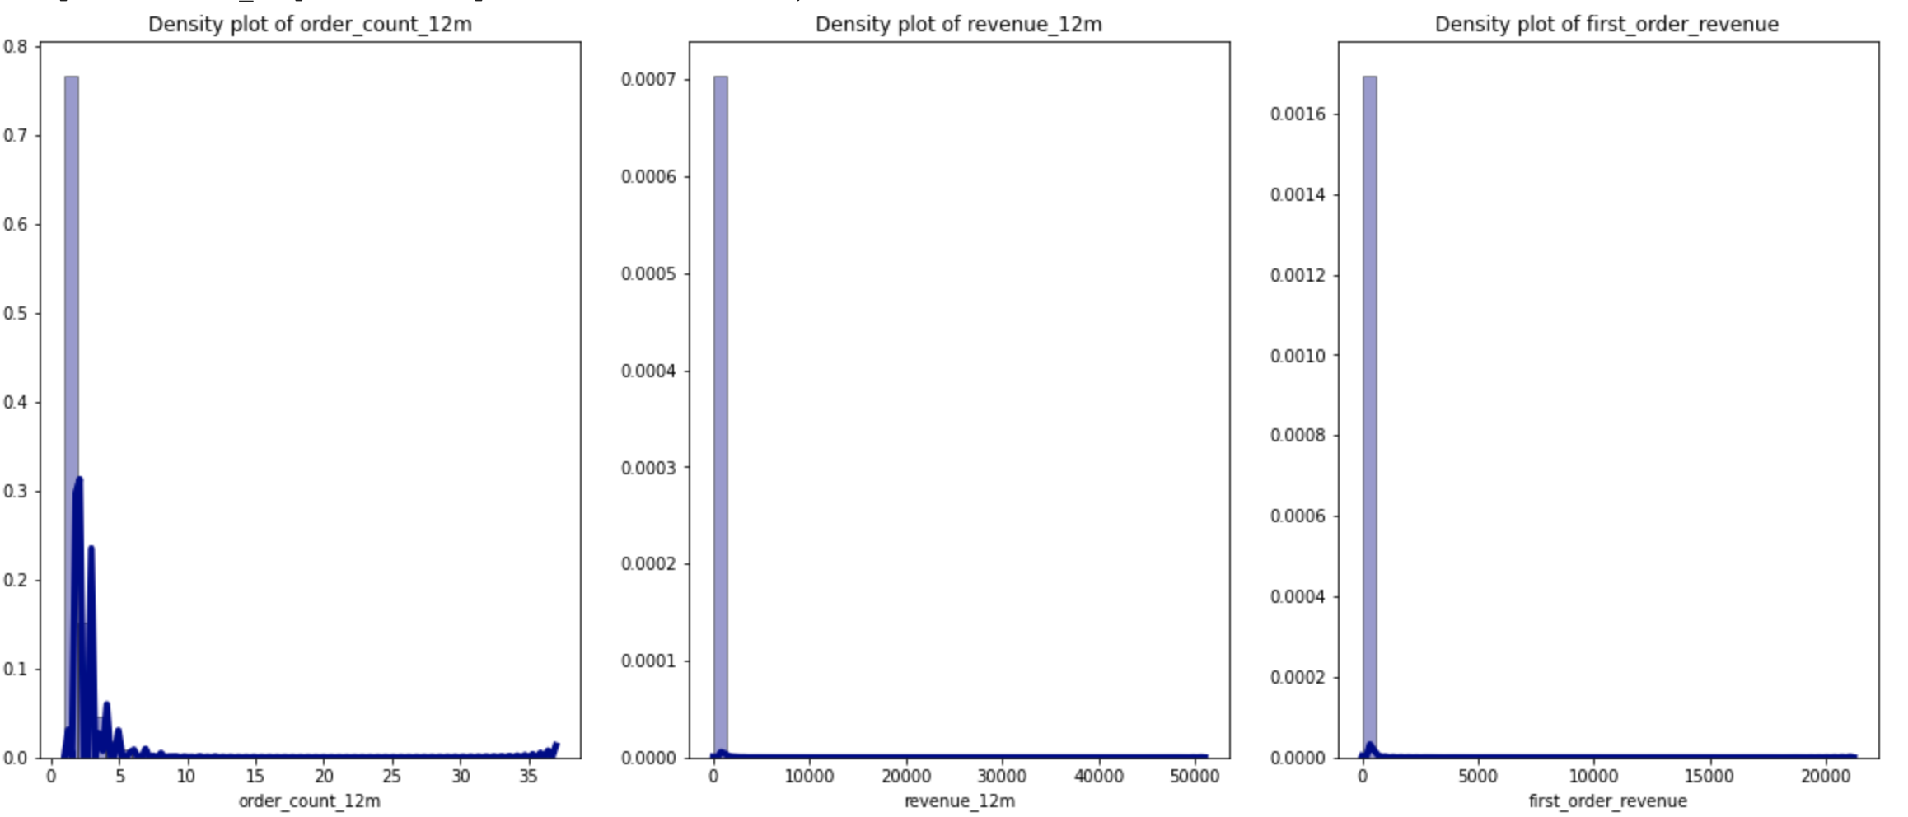

Not surprising, variables are highly skewed especially for monetary variables.

* So let’s look at the features again after log transformation.

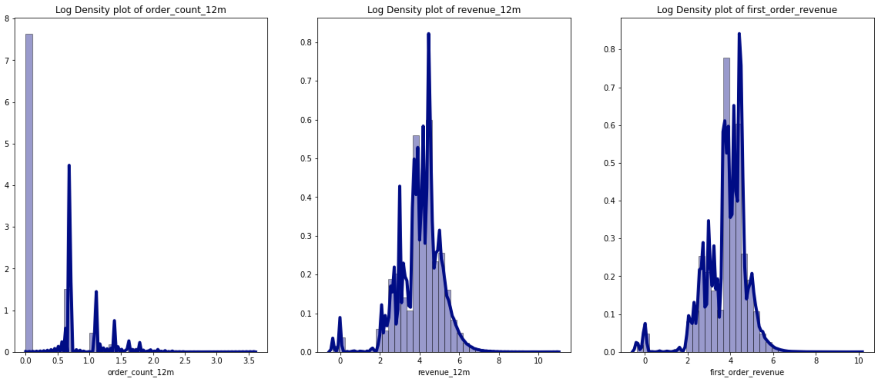

First_order_revenue and revenue_12m get closer to gaussian distribution except the little peak on the left by looking at their log density plots above. This tells us that the log transformation helps deal with the skewness for the continuous variables. For some model with gaussian assumption, the log transformation needs to be applied before feeding the data into the model.

* Let’s check the log distribution between single purchasers and repeating purchasers.

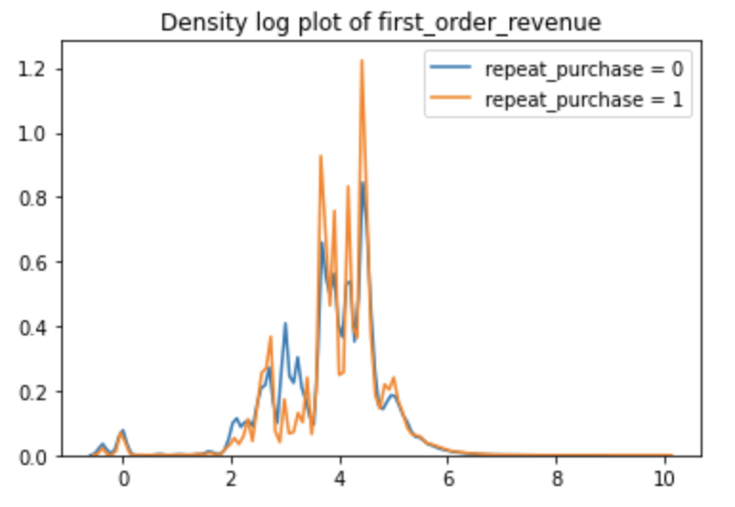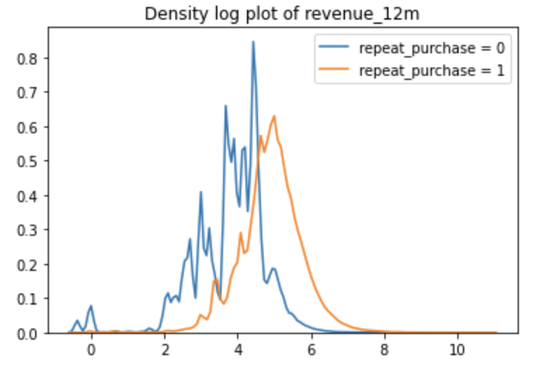

Two types of customers share a very similar distribution shape of first_order_reveue. And it seems that the repeat purchasers in general spend more on their purchasers. However, the distribution of revenue_12 is very different. It turns out the repeat purchasers’ revenue_12 is almost a gaussian distribution.

(3) Correlations

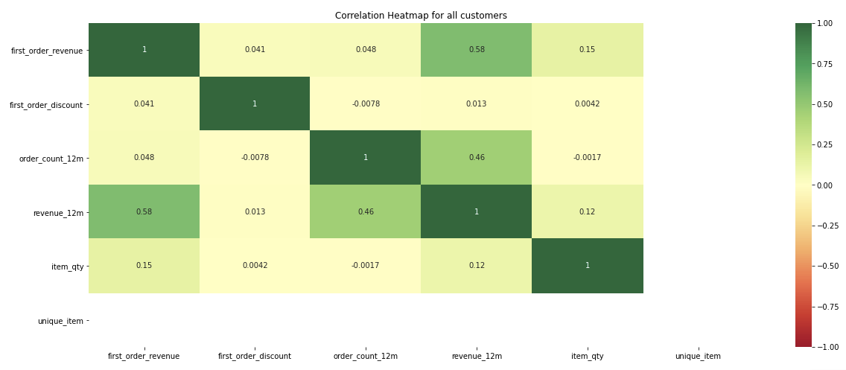

There is a strong correlation between first_order_reveue and revenue_12m and first_order_revenue and order_count_12m. Since the revenue_12m and order_count_12m are the proxy of the target variable. They will be dropped before modeling in order to prevent leakage. On the other hand, it tells us multicollinearity won’t be an issue when applying a linear model since there is no strong correlation among other variables.

## **5. Feature Engineering**

(1) Create dummy variables for: low cardinal categorical features

(2) Create binary variables for: features with only two classes

(3) Target encoding for high cardinal categorical features via the code below:

**from category_encoders import TargetEncoder**

**encoder = TargetEncoder()**

**train['country_code_encoded'] = encoder.fit_transform(train['country_code'], train['repeat_purchase'])**

**test['country_code_encoded'] = encoder.fit_transform(test['country_code'], test['repeat_purchase'])**

**train.drop(columns=['country_code','province_code'], inplace= True)**

**test.drop(columns=['country_code','province_code'], inplace= True)**

The pro of this method is that it turns high cardinal categorical variables into numerical variables which can be fed into ML models directly. The con is that it represents the training data set information which is very likely to cause overfitting.

## **6. Modeling and hyperparameter tuning**

Three classification models are trained. And Grid Search are applied for hyperparameter tuning.

(1) Logistic Regression

model = LogisticRegression(random_state=42,class_weight='balanced')

penalty = ['l2','l1']

solver = ['liblinear','lbfgs']

C = [1.0, 0.01,0.00001]

(2) Decision Tree

model = DecisionTreeClassifier(random_state=42,class_weight="balanced")

param_grid = {'criterion': ['gini','entropy'],

'splitter': ['best', 'random'],

'max_depth': [2,5],

'min_samples_split': [5, 50],

'min_samples_leaf': [2,10,15]

}

(3) RandomForest

model = RandomForestClassifier(random_state=42,class_weight="balanced")

param_grid = {'n_estimators': [200,300,500,800],

'max_depth': [3,5],

'min_samples_leaf': [10,30],

'min_samples_split': [25,50,80]

}

## **7. Evaluation and model selection**

Classification metrics - recall, precision, accuracy, f1 are considered to evaluate model performance and select the best model.

**Precision = TP / (TP +FP)**

It is implied as the measure of the correctly identified positive cases from all the predicted positive cases. It’s useful when minimizing FP. In other words, FP case costs a lot to the business. In this case, the marketing teams will spend effort and waste marketing budget to the customers who will come back again on their own.

**Recall = TP / (TP + FN)**

It is the measure of the correctly identified positive cases from all the actual positive cases. It is important when the cost of FN is high. In this case, the marketing teams will miss the chance to market to the people they won’t come and buy again by themselves

**Accuracy = (TP + TN) / (TP + TN + FP + FN)**

It is the measure of all the correctly identified cases. It is most used when all the classes are equally balanced. However, in this case classes are imbalanced.

**F1-score = 2 *(precision * recall / (precision + recall))**

This is the harmonic mean of Precision and Recall and gives a better measure of the incorrectly classified cases than the Accuracy Metric. And It can be used to penalize the extreme values.

We calculate testing F1 score during the hyperparameter tuning. Because for this business case, the marketing team won’t want to waste their marketing budget and at. In other words, there is a trade-off between precision and recall. Therefore F1 score is a good evaluation metric for this case.

The testing F1 scores are shown in the table below for all combinations of hyperparameters for each classifier.

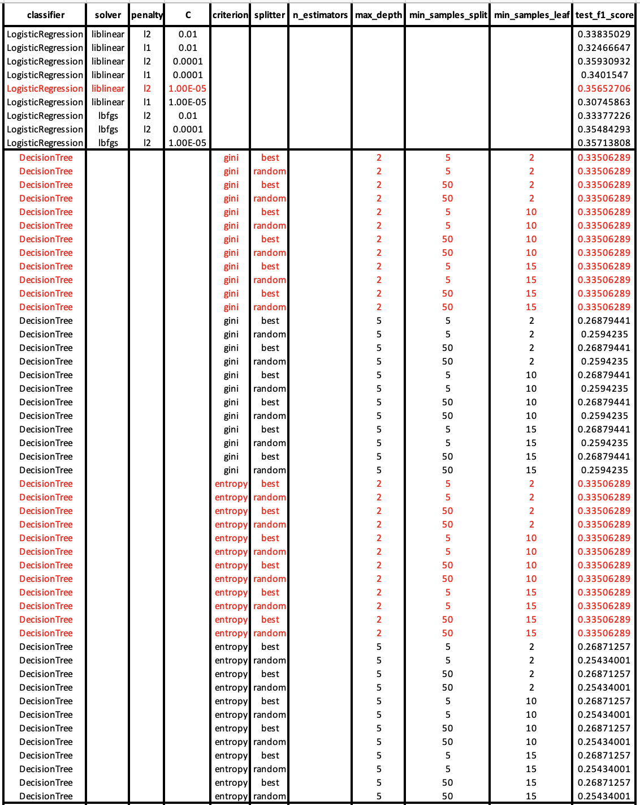

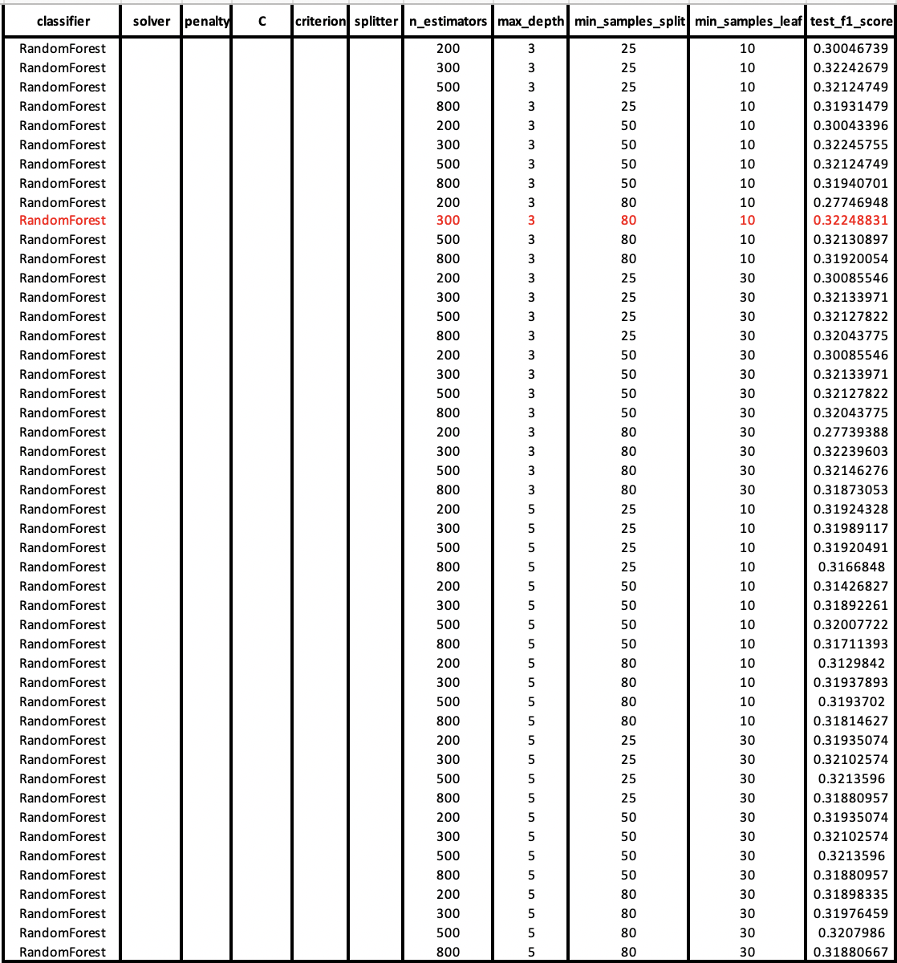

From the table above, in general the logistic regression classifier is outperformed due to overall higher f1 scores.

Red color highlights the winners within each classifier. And they are:

1. LogisticalRegression

|  |  |
| --- | --- |
| test_f1_score | 0.356527059347016 |
| Solver | liblinear |
| C | 0.00001 |
| penality | l2 |

1. DecisionTreeClassifier

|  |  |
| --- | --- |
| test_f1_score | 0.33506289308176 |
| criterion | gini |
| max_depth | 2 |
| min_samples_leaf | 5 |
| min_samples_split | 2 |
| splitter | random |

1. RandomForestClassifier

|  |  |
| --- | --- |
| test_f1_score | 0.322488312183951 |
| max_depth | 3 |
| min_samples_leaf | 10 |
| min_samples_split | 80 |
| n_estimator | 300 |

Comparing testing results from three models:

|  |  |  |  |  |  |  |
| --- | --- | --- | --- | --- | --- | --- |
| **classifiers** | **Precision** | **Recall** | **Accuracy** | **AUC** | **test_f1_score** | **train_f1_score** |
| LogisticRegression | 0.242399 | 0.673744 | 0.625348 | 0.603158 | 0.356527 | 0.429911 |
| DecisionTreeClassifier | 0.267613 | 0.447971 | 0.677015 | 0.587915 | 0.335063 | 0.400246 |
| RandomForestClassifier | 0.295248 | 0.355266 | 0.740787 | 0.583513 | 0.322488 | 0.465093 |

The LogisticRegression model has the highest f1 score which could be considered as the best model here.

Even though the accuracy looks better than other metrics but in this case, looking at accuracy is misleading due to the imbalanced classes. However, all models have low precision, recall, auc and f1 score. This means the models are getting trouble of making good predictions. So it’s worth going back to the beginning and considering what other information/data would be added into the model.

## **8. Explanation**

1. Logistic Regression

LogisticRegression(random_state=42,class_weight='balanced',penalty = 'l2',C= 0.00001, solver='liblinear')

1. Check the coefficients for each feature:

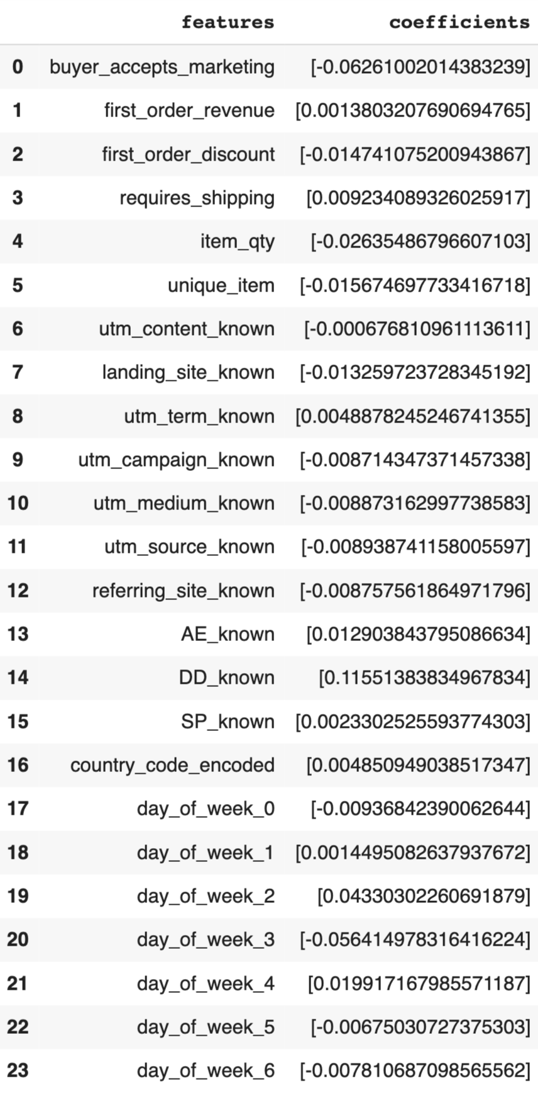

1. The Intercept:

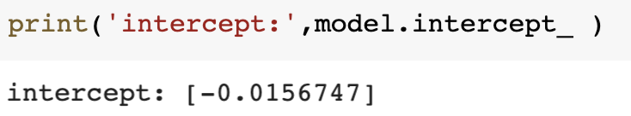

1. Insights:

Overall, all the coefficients are small.

* The coefficient of ‘Dotdigial_known’ seems significant by comparison to other features. This is not surprising because the active or super fans of the artists will subscribe to the store and get updates from the store when new items are released.
* Looking at the day of week, the coefficient of Wednesday (‘day_of_week_2’) is positive and larger than others. This is an interesting insight which tells us that fans are more likely to purchase on Wednesday.

(2) Decision tree

1. Plot decision tree

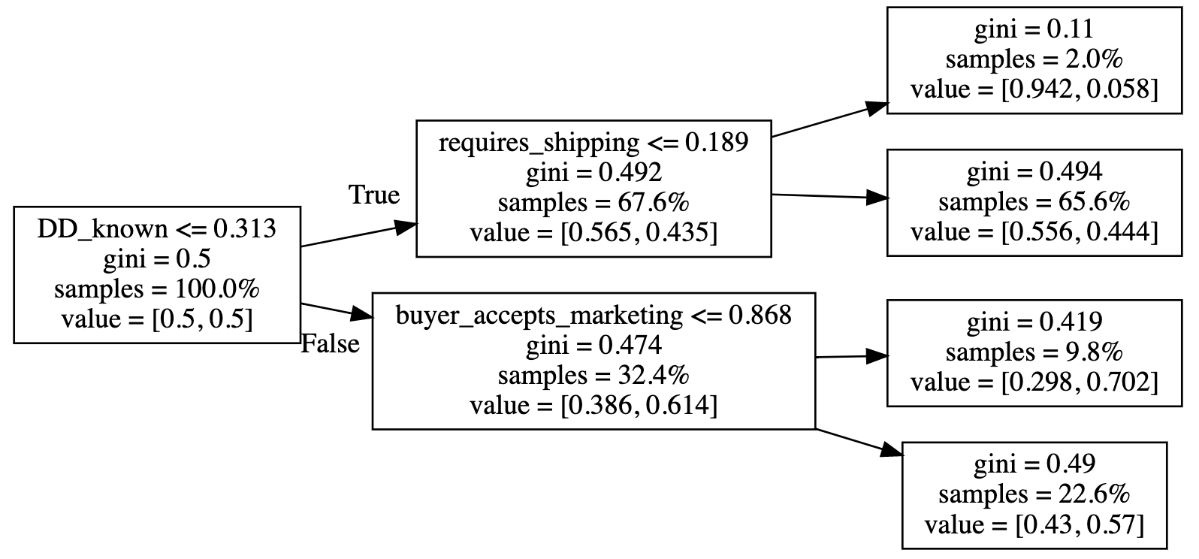

1. General insights:

Our starting point is the first node to the left. Here we have 100% of samples (obviously, we haven’t even started splitting), the proportion between classes is a perfect 50/50 (we balanced the data before building the ‘tree’), and the gini is 0.5, as bad as it can possibly be as a random guess.

Looking at the leaves (ending points), the second leaf captures the majority of the people with samples = 65.6%. However the gini index is very close to 0.5. Unfortunately this is a bad segmentation result.

The first leaf with the lowest gini index (0.11) among all four leaves shows a good segment. But the samples =2%. So this tree model is doing a good job on this small portion of the customers. But it fails on classification on the majority of the customers.

These insights are also reflected by evaluation metrics. The precision of the decision tree model is very low.

## **9. Optimize and further work**

Overall, all three models are not able to do a good prediction job due to lack of useful features. In this case, we try to predict customers behavior - whether they will buy again or not. However, we suffer the lack of behavioral data ( eg. touchpoints from any digital service), personality related data ( eg, personal preference) and etc.

Therefore there are some further thoughts:

1. Incorporate digital touchpoints. For example, Google analytics dataset could be considered a good start since it gives out customer’s browsing behaviors.
2. Content based event information. Because the ecommerce stores represent artists' shops. The products are associated with artists songs, concerts or other music related activities. The streaming behavior could be considered a good start.
3. Personality characters information. For example, personal preference regarding product type or music genre and etc.
4. Seasonality: holidays like X’mas, Black Friday, New year and etc. This information can be extracted from the order date variable. They might provide useful information to increase model prediction capability.